

**Salesbit**

A Major Project Report Submitted In partial fulfillment For the award of the Degree of **BACHELOR OF TECHNOLOGY** In the Department of Computer science and Engineering

**Submitted by**:

Chirag Paliwal

Hemang Singh Baya

**Department of Computer Science and Engineering**

**TECHNO INDIA NJR INSTITUTE OF TECHNOLOGY**

RAJASTHAN TECHNICAL UNIVERSITY

**May 2022**

**TECHNO INDIA NJR INSTITUTE OF TECHNOLOGY**



**CERTIFICATE**

This is to certify that this project report “Salesbit” is the confide work of “Hemang Singh Baya and Chirag Paliwal” who have carried out the project work under my supervision. I approve this project for submission of the Bachelor of Technology in the Department of Computer Science and Engineering, Techno India NJR Institute of Technology, affiliated to Rajasthan Technical University, Kota.

Mr. Aditya Maheshwari

Project In-charge

Department of Computer Science

**ABSTRACT**

**1. Purpose**

**1.1. Introduction**

This Software Requirements Specification provides a complete description of all the functions and specifications of the webapp Salesbit.

The main objective of this web application is to ease the workflow of mining industries by making them able to manage all their inventory and sales data effortlessly and analysing the reports for any scope of improvement.

**1.2. Scope**

The scope of this project is very broad as it can be used by any stone mining industry, it could be granite, marble, etc. Some other advantages are :

-> As it is a webapp, it can be used on any platform.

-> Data updates instantly, so it can be used by any person regardless of where he/she is located, as they view the real-time data.

**2. Document overview**

The remainder of this document is 8 chapters, the first providing introduction to the project. It lists all the functions performed by the system. The second chapter consists of software requirements specification. The third chapter provides details about system analysis and design. The fourth chapter gives data dictionary information. The fifth chapter consists of snapshots of the complete project. The sixth chapter gives testing for the project. The seventh chapter tells about the conclusion and future enhancements of the project. The final chapter concerns the bibliography.

**ACKNOWLEDGEMENT**

It gives me immense pleasure to express my deepest sense of gratitude and sincere thanks to my highly respected and esteemed guide **Mr. Aditya Maheshwari (Project In-charge), TINJRIT** for their valuable guidance, encouragement, and help in completing this work. Their useful suggestions for this whole work and co-operative behavior are sincerely acknowledged. At the end, I would like to express my sincere thanks to all my friends and others who helped me directly or indirectly during this project work.

Hemang Singh Baya

Chirag Paliwal

Place - Udaipur

Date - 28/05/2022

**TABLE OF CONTENTS**

**Table of Contents**

Abstract....................................................................................................................................... 3

Acknowledgement ...................................................................................................................... 4

Table of Contents ...................................................................................................................... 5-8

List of Tables .............................................................................................................................. 9

List of Figures ..............................................................................................................................10

**CHAPTER – 1 Introduction**....................................................................................................11-12

Introduction .................................................................................................................................. 11

1.1.Purpose.................................................................................................................................. 11

1.2.Overall Description ........................................................................................................... 11-12

**CHAPTER – 2 Software Requirement Specification** ......................................................... 13-17

2.1. Purpose................................................................................................................................. 13

2.2. Overall Description................................................................................................................ 14

2.2.1. Functional Requirements definitions ................................................................................. 15

2.2.2. Use Cases.......................................................................................................................... 15

2.2.3. Non – Functional Requirements........................................................................................ 14

2.3. Requirement Specification ................................................................................................... 15

2.3.1. External interface specifications......................................................................................... 15

2.3.2. Functional Requirements .................................................................................................. 15

2.4. Hardware Specification ........................................................................................................ 16

2.5. Software Specification........................................................................................................... 16

2.6. Hardware and Software Requirements in detail ................................................................... 17

**CHAPTER – 3 System Analysis and Design** ...................................................................... 18-22

3.1. Study & Weaknesses of current system .............................................................................. 18

3.2 Requirements of new system .............................................................................................. 18

3.3. Feasibility Study ................................................................................................................. 19

3.4. Features of new System ..................................................................................................... 19

3.5. Data flow diagram …........................................................................................................... 20

3.6. UML Modeling………........................................................................................................... 20

3.6.1. Activity Diagram …........................................................................................................... 21

3.6.2. Class Diagram ….............................................................................................................. 21

3.6.3. Context Diagram .............................................................................................................. 22

3.6.4. Sequence Diagram .......................................................................................................... 22

**CHAPTER – 4 Data Dictionary** ............................................................................................ 23-28

4.1. Table Details .......................................................................................................................23

4.2. E-R Diagram ................................................................................................................... 23-28

**CHAPTER - 5 Screen Shots** ................................................................................................ 29-37

5.1. Admin Master ..................................................................................................................... 29

5.2. User Master ........................................................................................................................ 37

**CHAPTER – 6 Testing** .......................................................................................................... 38-43

**CHAPTER – 7 Conclusion and Future Enhancements** ..................................................... 44-45

7.1. Limitations .......................................................................................................................... 44

7.2. Future Enhancements ........................................................................................................ 44

7.3. Conclusion .........................................................................................................................45

**CHAPTER – 8 Project Timeline…………………………**…...................................................... 44

**CHAPTER – 9 Bibliography and Dependencies** .................................................................. 45

**List of Tables**

| **Table No.** | **Table Name** | **Table Page** |
| --- | --- | --- |
| Table 2.1 | Glossary | 11 |
| Table 4.1 | User Login | 24 |
| Table 4.2 | Block | 24-25 |
| Table 4.3 | Quarry | 26 |
| Table 4.4 | Yard | 26 |
| Table 4.5 | Unit | 27 |
| Table 4.6 | Party | 27 |
| Table 6.1 | Test Report | 42 |

**List of Figures**

| **Figure No.** | **Figure Name** | **Page Number** |
| --- | --- | --- |
| Fig 1 | Level 0 DFD | 20 |
| Fig 2 | Level 1 DFD | 20 |
| Fig 3 | Level 2 DFD | 21 |
| Fig 4 | UML Class Diagram | 22 |
| Fig 5 | E-R Diagram | 38 |
| Fig 6 | Project Timeline | 46 |

**CHAPTER – I**

**INTRODUCTION**

**1. Purpose**

**1.1. Introduction**

This Software Requirements Specification provides a complete description of all the functions and specifications of the webapp Salesbit.

The main objective of this web application is to ease the workflow of mining industries by making them able to manage all their inventory and sales data effortlessly and analyzing the reports for any scope of improvement.

**1.2. Scope**

The scope of this project is very broad as it can be used by any stone mining industry, it could be granite, marble, etc. Some other advantages are :

-> As it is a webapp, it can be used on any platform.

-> Data updates instantly, so it can be used by any person regardless of where he/she is located, as they view the real-time data.

**1.1.3. References**

[IEEE] The applicable IEEE standards are published in “IEEE Standards Collection,” 2001 edition.

[Bruade] The principal source of textbook material is “Software Engineering: An Object-Oriented Perspective” by Eric J. Bruade (Wiley 2001).

**1.1.4. Document Overview**

The remainder of this document is 8 chapters, the first providing introduction to the project. It lists all the functions performed by the system. The second chapter consists of software requirements specification. The third chapter provides details about system analysis and design. The fourth chapter gives data dictionary information. The fifth chapter consists of snapshots of the complete project. The sixth chapter gives testing for the project. The seventh chapter tells about the conclusion and future enhancements of the project. The final chapter concerns with the bibliography. This document is meant for describing all the features and procedures that were followed while developing the system. This document specially mentions the details of the project how it was developed, the primary requirement, as well as various features and functionalities of the project, and the procedures followed in achieving these objectives.

**CHAPTER – II**

**SOFTWARE REQUIREMENT SPECIFICATION**

**2.1. Purpose**

**2.1.1. Introduction**

This Software Requirements Specification provides a complete description of all the functions and specifications of the webapp Salesbit**.**

The main objective of this web application is to ease the workflow of mining industries by making them able to manage all their inventory and sales data effortlessly and analyzing the reports for any scope of improvement.

**2.1.2. Scope**

The scope of this project is very broad as it can be used by any stone mining industry, it could be granite, marble, etc. Some other advantages are:

-> As it is a webapp, it can be used on any platform.

-> Data updates instantly, so it can be used by any person regardless of where he/she is located, as they view the real-time data.

**2.1.3. Glossary**

**Table 2.1**

| **TERM** | **Definition** |
| --- | --- |
| Admin | Can monitor sales, view reports, assign roles |
| Manager | Can add or remove data |
| Salesman | Can view inventory, and sell/reserve items |
| QA | Quality Assurance |
| SCMP | Software Configuration Management Plan |
| SDD | Software Design Document |
| SQAP | Software Quality Assurance Plan |
| SRS | Software Requirement Specification |

**2.1.4. References**

[IEEE] The applicable IEEE standards are published in “IEEE Standards Collection,” 2001 edition.

[Bruade] The principal source of textbook material is “Software Engineering: An Object-Oriented Perspective” by Eric J. Bruade (Wiley 2001).

**2.1.5. Document Overview**

The remainder of this document is 8 chapters, the first providing introduction to the project. It lists all the functions performed by the system. The second chapter consists of software requirements specification. The third chapter provides details about system analysis and design. The fourth chapter gives data dictionary information. The fifth chapter consists of snapshots of the complete project. The sixth chapter gives testing for the project. The seventh chapter tells about the conclusion and future enhancements of the project. The final chapter concerns with the bibliography.

**2.2. Overall Description**

This web application covers aspects of stock and sales management:-

1. A place to see records of all mined items.
2. Manage authority
3. Managing location of items and items in transit
4. Managing the sales workflow

**2.2.1. Functional requirements**

By using this webapp, a user can store data of all the mining processes that are being carried out in their company.

Firstly a block is extracted from the mine and the manager can add attributes like Block number, Yard, Date of purchase, Quarry from which block is extracted, Grade of the block, Shade of the block, Dimensions of the block, Transportation cost, Purchase cost, etc. The manager can also add or remove Quarries, Parties, Companies, Yards, etc. The manager can move blocks to different yards, process the block into slabs, and polish slabs.

Salesmen can view the inventory which is added by the manager and reserve or sell the items to parties and generate invoices.

Admin can view all the stock and sales activity and view reports in pdf(s).

**2.2.2. Use cases**

This system will be used in Three User Modules which are Administrator, Manager, and Salesman. As all of these have different requirements the modules are designed to meet their needs and avoid any type of confusion. The Uses of all three User Modules have been described below.

[1] User can do the following functions in the Administrator Module

-> View overall Stock/Sales figures.

-> Assign Roles to other users (Manager or Salesman).

-> View Sales activity.

[2] User can do the following functions in the Administrator Module

-> Add/Remove Block.

-> Add/Remove Company.

-> Add/Remove Quarry.

-> Add/Remove Yard.

-> Add/Remove Party.

-> Add/Remove Units.

-> Process/Move blocks.

[3] User can do the following functions in the Salesman Module

-> View Inventory.

-> Sell or Reserve Blocks/Slabs.

**2.3. Hardware & Software Requirements**

**2.3.1 Hardware:**

As this is a web application it runs on a browser, preferably Google Chrome.

So the minimum hardware requirements for smooth functioning of this webapp are:

1. Windows -

Windows 7, Windows 8, Windows 8.1, Windows 10 or later

* An Intel Pentium 4 processor or later that's SSE3 capable

Note: Servers require Windows Server 2008 R2, Windows Server 2012, Windows Server 2012 R2, or Windows Server 2016

1. Mac -

To use Chrome browser on Mac, you'll need:

* OS X El Capitan 10.11 or later

1. Linux -

64-bit Ubuntu 18.04+, Debian 10+, openSUSE 15.2+, or Fedora Linux 32+

An Intel Pentium 4 processor or later that's SSE3 capable

1. Android -

Android Marshmallow 6.0 or later

**2.3.2 Software:**

It is recommended to run this application in google chrome browser version-102.0.5005.62

**CHAPTER – III**

**SYSTEM ANALYSIS AND DESIGN**

**3.1. Analysis of current system**

Currently there is no proper system to store data.

Use of pen and paper or MS excel is used.

Sales and stock management in most of the stone excavation industries are done without maintaining proper records and inconsistent methods. This includes:-

1. A well-defined structure to manage the details of excavated items and to convert them into other articles while preserving relations to the parent article at a later point.
2. Managing authority over who can make changes in the records.
3. A way to manage locations of mined articles.
4. Manage items in transit.
5. Make and manage sales
6. Maintain a state of items while the payment is pending.

**3.2. Benefits of using this ERP over current practice:**

This webapp can be used by anyone in the stone excavation industry for streamlining their workflow and managing data without any fuss. It can save a lot of man-hours as data is easily accessible and editable.

Main problems that this ERP solves are -

-> Saves time as everything is well-formatted

-> Calculate accurate results as every formula used for calculations like weight or slab count is already present in this ERP.

-> Saves money as only one person is needed to record data.

-> All reports are generated in PDF format so records are easily stored and maintained

**3.3. Limitations of this webapp:**

This webapp requires internet connectivity at all times to function.

Note-taking and data management are still preferred to be done on paper because the working staff is not accustomed to using computers.

**3.4. Data Flow Diagram (DFD)**

The DFD (also known as bubble chart) is a simple graphical formalism that can be used to represent a system in terms of the input data into the system, various processes carried on these data, and the output data generated by the system. The main reason why the DFD technique is so popular is because the fact that the DFD is a very simple formalism – it is simple to understand and use. A DFD model uses a very limited number of primitive symbols to represent the functions performed by a system and the data flow among the functions. Starting with a set of high-level functions that a system performs, a DFD

model hierarchy represents various sub-functions.

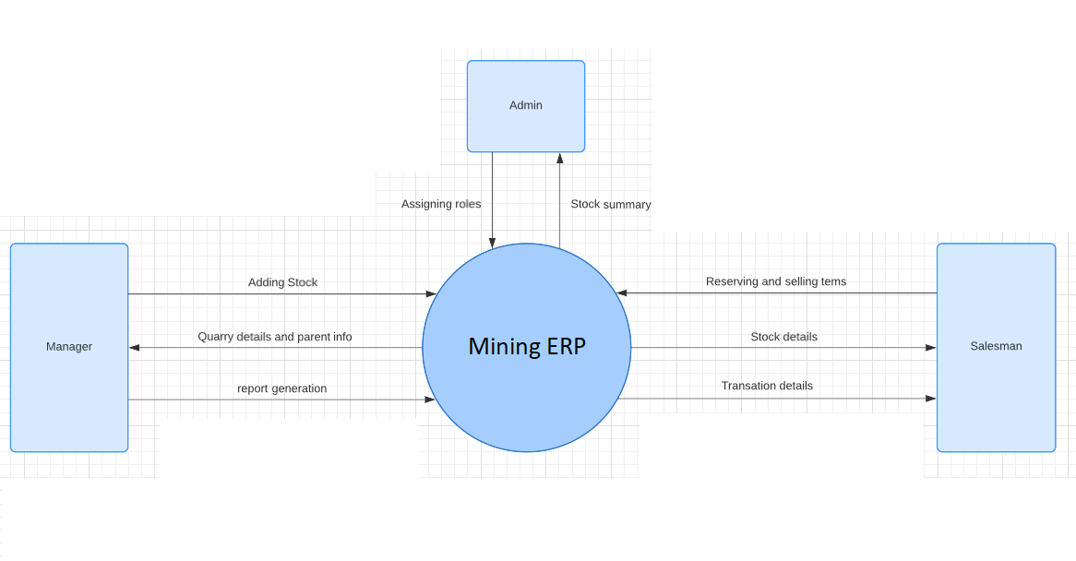

Fig 1. Level 0 DFD diagram for mining ERP

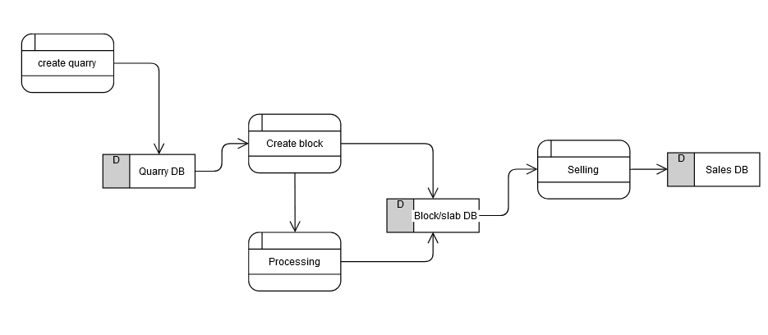

Fig 2. Level 1 DFD diagram for a mining ERP

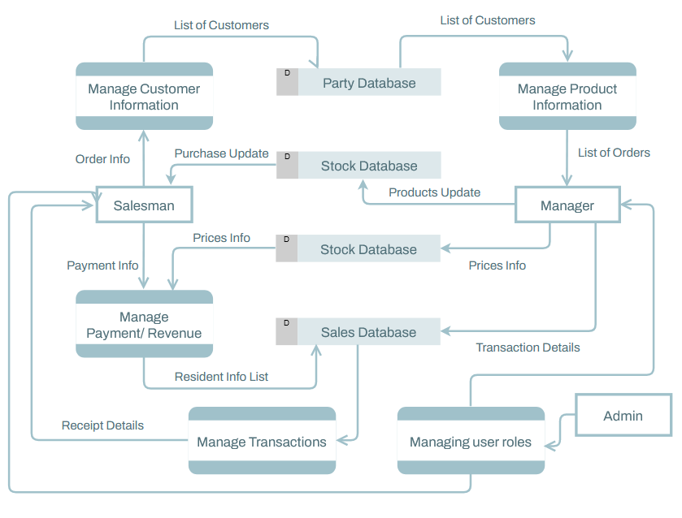

Fig 3. Level 2 DFD for a mining ERP

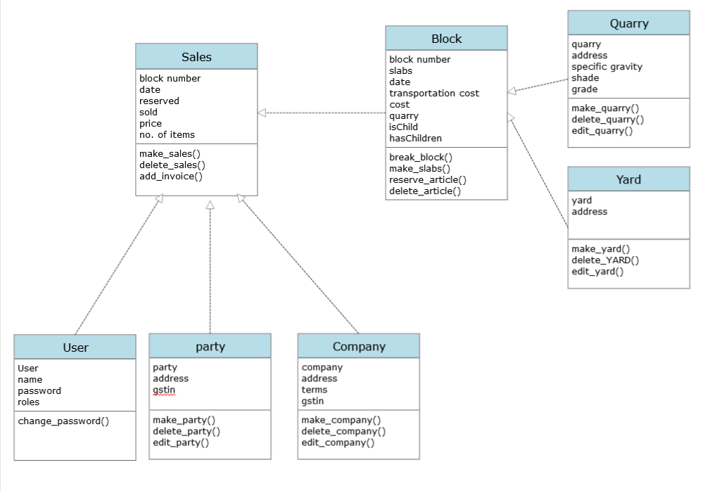

Fig 4. UML class diagram

**CHAPTER – IV**

**DATA DICTIONARY**

**Data Dictionary**

A data dictionary is a catalogue-a-repository of the elements in a system. As the

name suggests, their elements centre on data and the way they are structured to meet user requirements and organisation needs. In a data dictionary, you will find a list of all the elements composing the data flowing through a system. The major elements are data flows, data stores, and processes. The data dictionary stores details and descriptions of these elements.

If analysis wants to know characters are in a data item by what other names it is referenced in the system, or where it is referenced in the system, or where it is issued in the system, they should be able to find the answers in issued in the system, they should be able to find the answer in the properly developed data dictionary.

The Dictionary contains two types of descriptions for the data following through the system.

**1. Data Elements**

The most fundamental data is the elements. They are building blocks for all other data in the system. Data elements are also alternatively known as fields, data items, or elementary items.

**2. Data Structure**

A data structure is a set of items that are related to one another and described

components in the system.

**4.1. Table Details**

**Table 4.1. User Login**

| **Field Name** | **Description** | **Constraints** | **Size** | **Data Type** |
| --- | --- | --- | --- | --- |
| Username | Unique Username of the user |  | 70 | varchar |
| Password | User Password |  | 70 | varchar |

**Table 4.2 Block**

| **Field Name** | **Description** | **Constraints** | **Size** | **Data Type** |
| --- | --- | --- | --- | --- |
| Block Number | Unique number of a block | Primary key | MAX | varchar |
| Yard | Block’s current location | Foreign Key | MAX | Varchar |
| Yard History | Tells the location history of the block |  | MAX | varchar |
| Date | Purchase date of the block |  | 10 | varchar |
| HSN Code | A code which is used to identify a material | Foreign Key | MAX | varchar |
| Quarry | Quarry from which block is extracted | Foreign Key | MAX | varchar |
| Grade | Grade of the Block | Foreign Key | MAX | varchar |
| Shade | Colour tint of the Block | Foreign Key | MAX | varchar |
| Weight | Weight of the Block |  | MAX | Int |
| Length | Length of the Block |  | MAX | Int |
| Height | Height of the Block |  | MAX | Int |
| Width | Width of the Block |  | MAX | Int |
| Note | Any extra description that user might want to add |  | MAX | varchar |
| Slabs | Whether the Block is processed or not |  | MAX | Boolean |
| Sold | Whether the Block is Sold or not |  | 1 | Int |
| Reserved | Whether the Block is Reserved or not |  | 1 | Int |
| Transportation Cost | Cost of transportation of the Block |  | MAX | Float |
| Processing Cost | Cost of Processing the Block |  | MAX | Float |
| Processor | Name of Block Processor |  | MAX | varchar |
| Layer Type | Layer Type of the Block |  | MAX | varchar |
| Unit | Unit in which the dimensions of the Block is measured | Foreign Key | MAX | varchar |

**Table 4.3 Quarry**

| **Field Name** | **Description** | **Constraints** | **Size** | **Data Type** |
| --- | --- | --- | --- | --- |
| Quarry | Quarry from which block is extracted | Primary Key | MAX | varchar |
| Grade | Grade of the Block |  | MAX | varchar |
| Shade | Colour tint of the Block |  | MAX | varchar |
| Quarry Address | Adress of the Quarry |  | MAX | varchar |
| Specific Gravity | Specific Gravity of the Block that is extracted |  | MAX | Float |
| Block Type | Type of the block that is extracted |  | MAX | varchar |
| HSN Code | HSN code of extracted material |  | MAX | varchar |
| HSN Code of slabs | HSN Code of processed Material |  | MAX | varchar |

**Table 4.4 Yard**

| **Field Name** | **Description** | **Constraints** | **Size** | **Data Type** |
| --- | --- | --- | --- | --- |
| Yard | Name of the Yard | Primary Key | MAX | varchar |
| Yard Address | Address of the Yard |  | MAX | varchar |

**Table 4.5 Unit**

| **Field Name** | **Description** | **Constraints** | **Size** | **Data Type** |
| --- | --- | --- | --- | --- |
| Unit | Unit in which Block is Measured | Primary Key | MAX | varchar |
| Factor | Factor in mm. |  | MAX | Float |

**Table 4.6 Party**

| **Field Name** | **Description** | **Constraints** | **Size** | **Data Type** |
| --- | --- | --- | --- | --- |
| Party | Name of Buyer | Primary Key | MAX | varchar |
| Party Address | Address of Buyer |  | MAX | varchar |
| GSTIN | GST no. of buyer’s company |  | MAX | varchar |

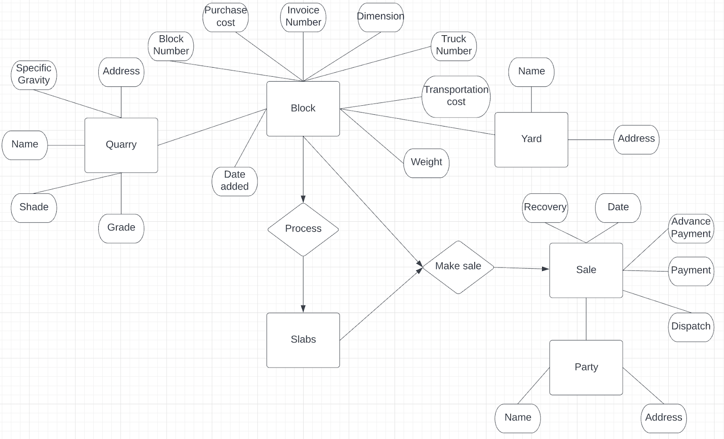

Fig 5. E-R Diagram

**CHAPTER – V**

**SCREENSHOTS**

**5.1 Login and sign-up page**

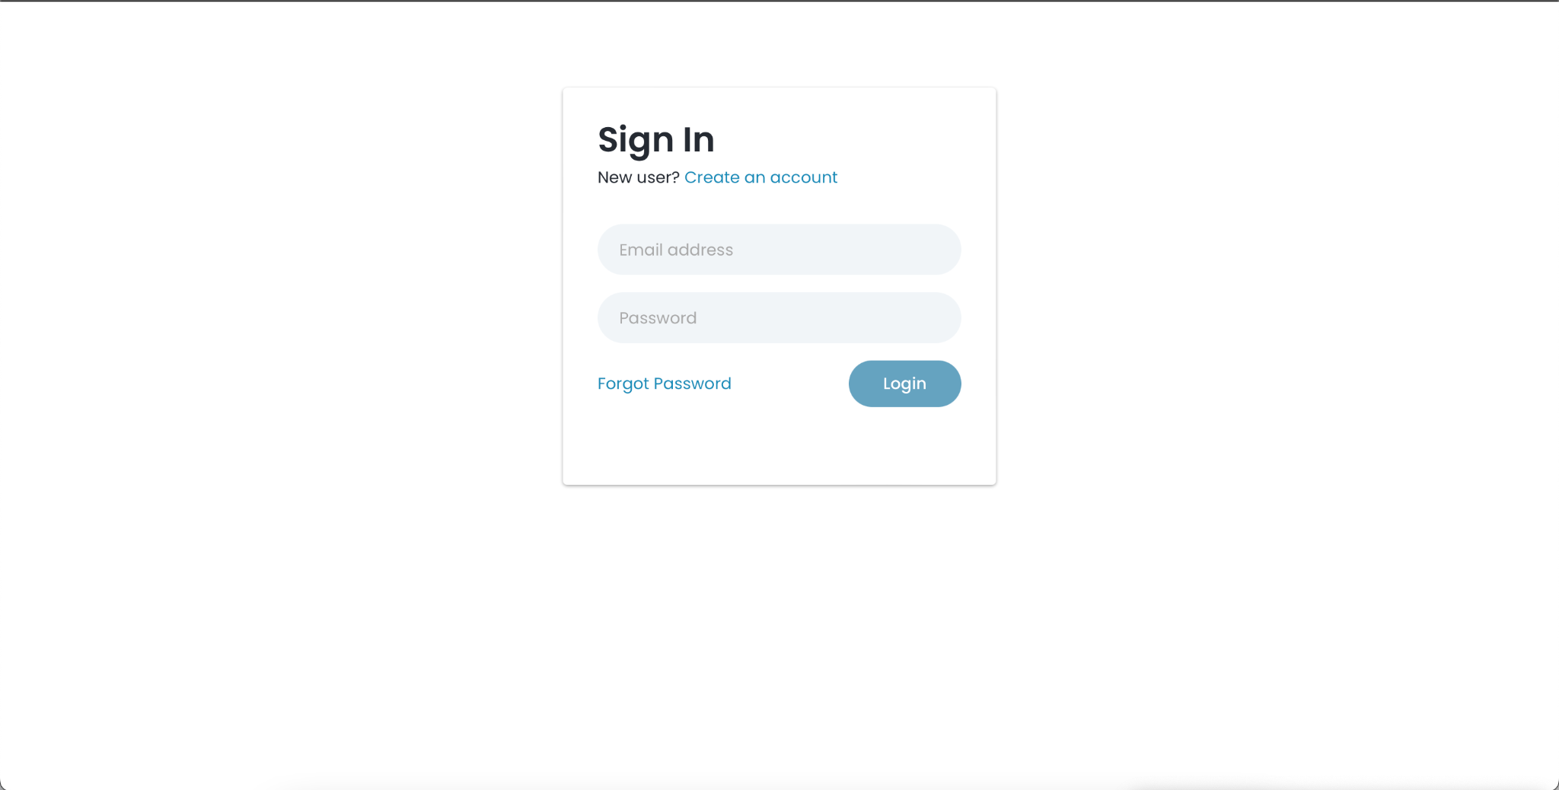

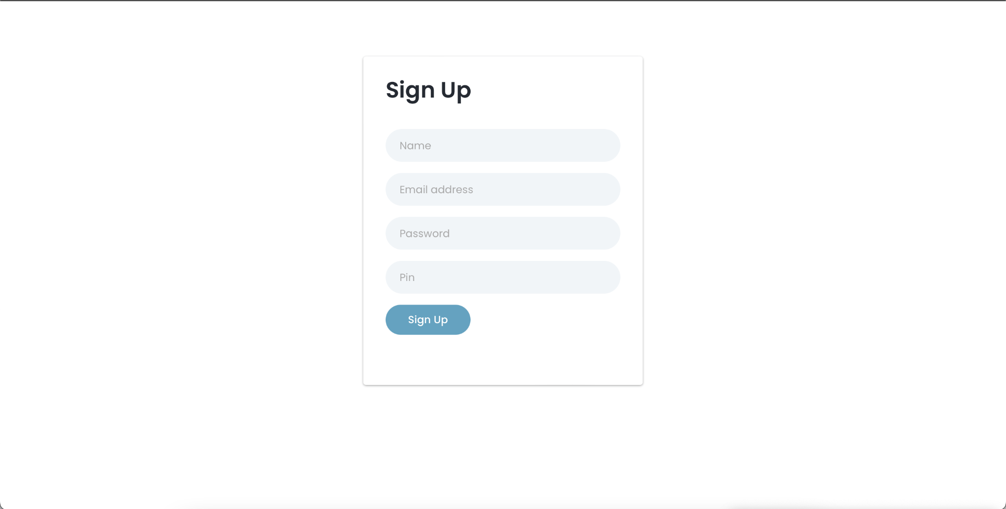

**5.2 Admin’s Dashboard**

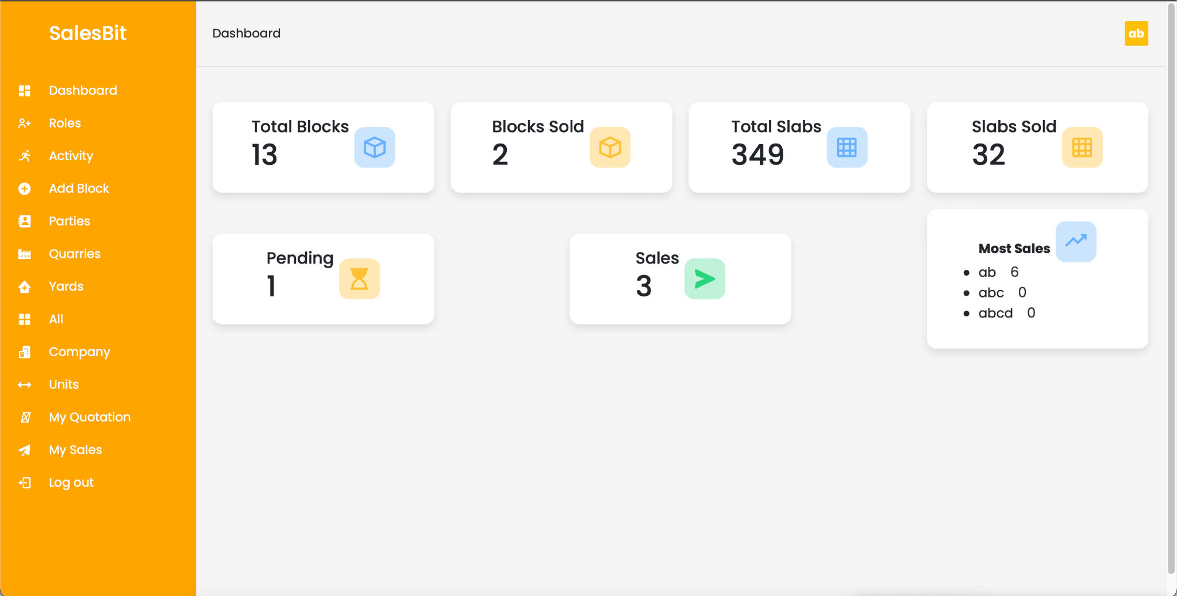

**5.2.1 Role Assignment**

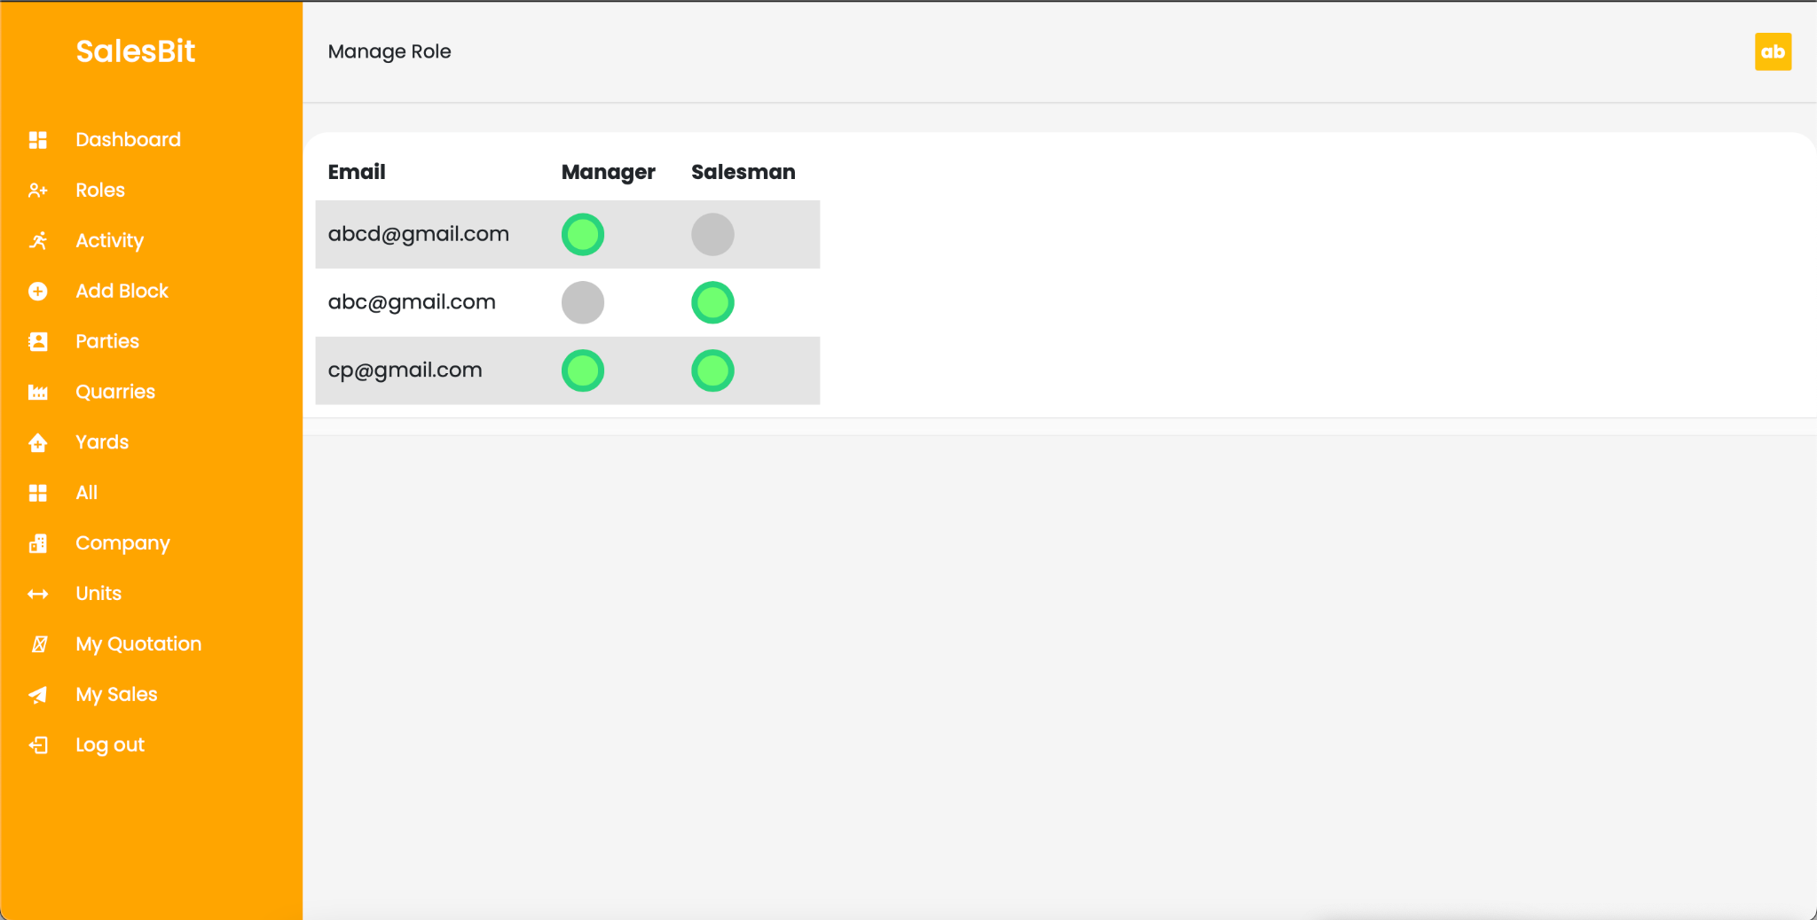

**5.2.3 Sales Activity and report**

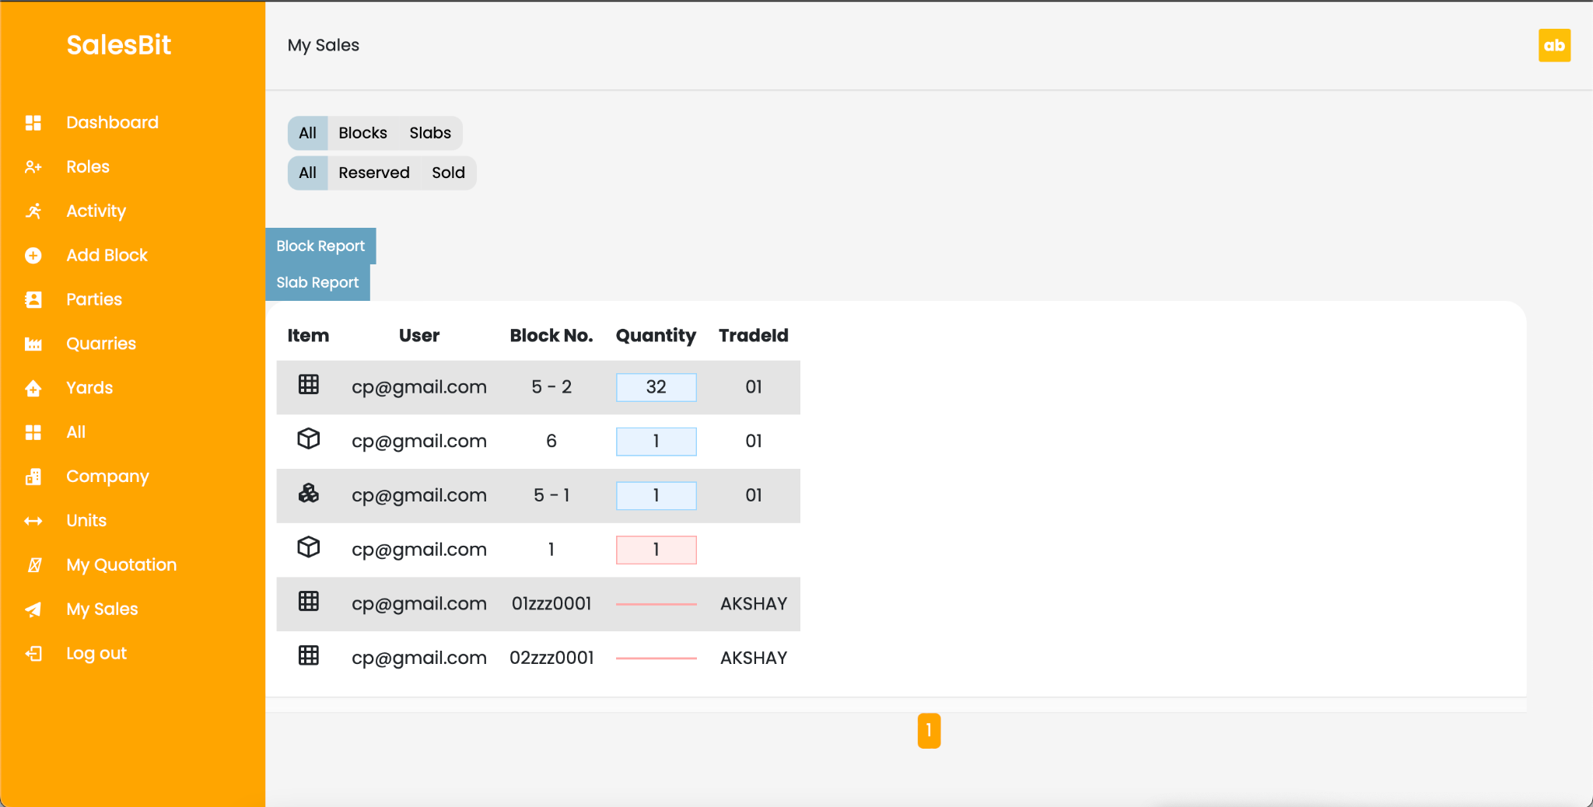

**5.3 Add block**

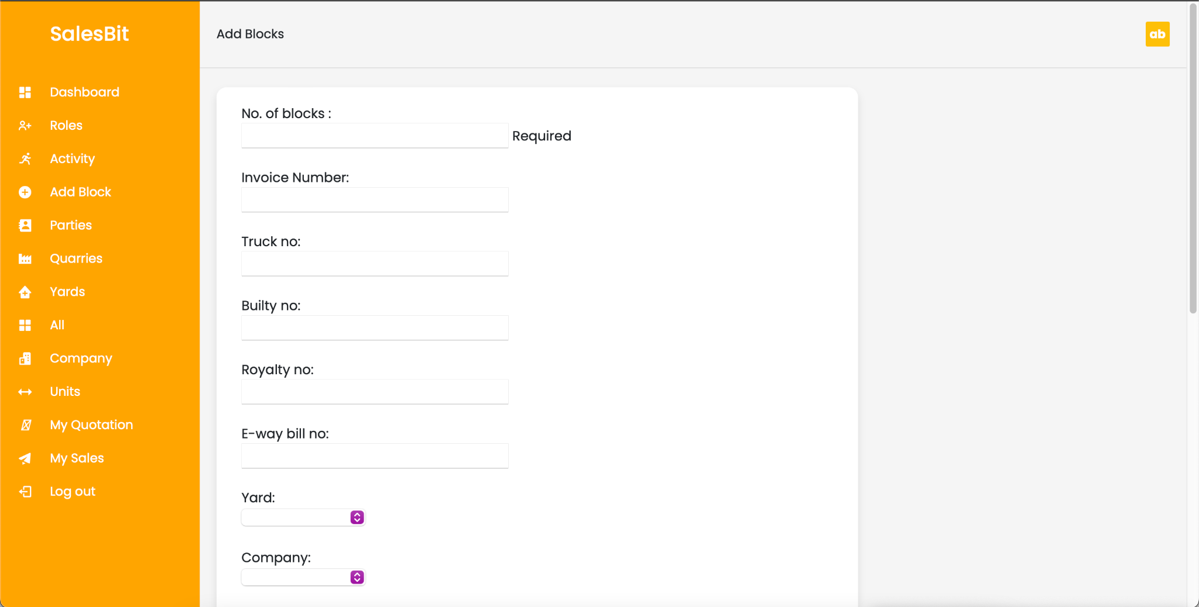

**5.3.1 Add Block**

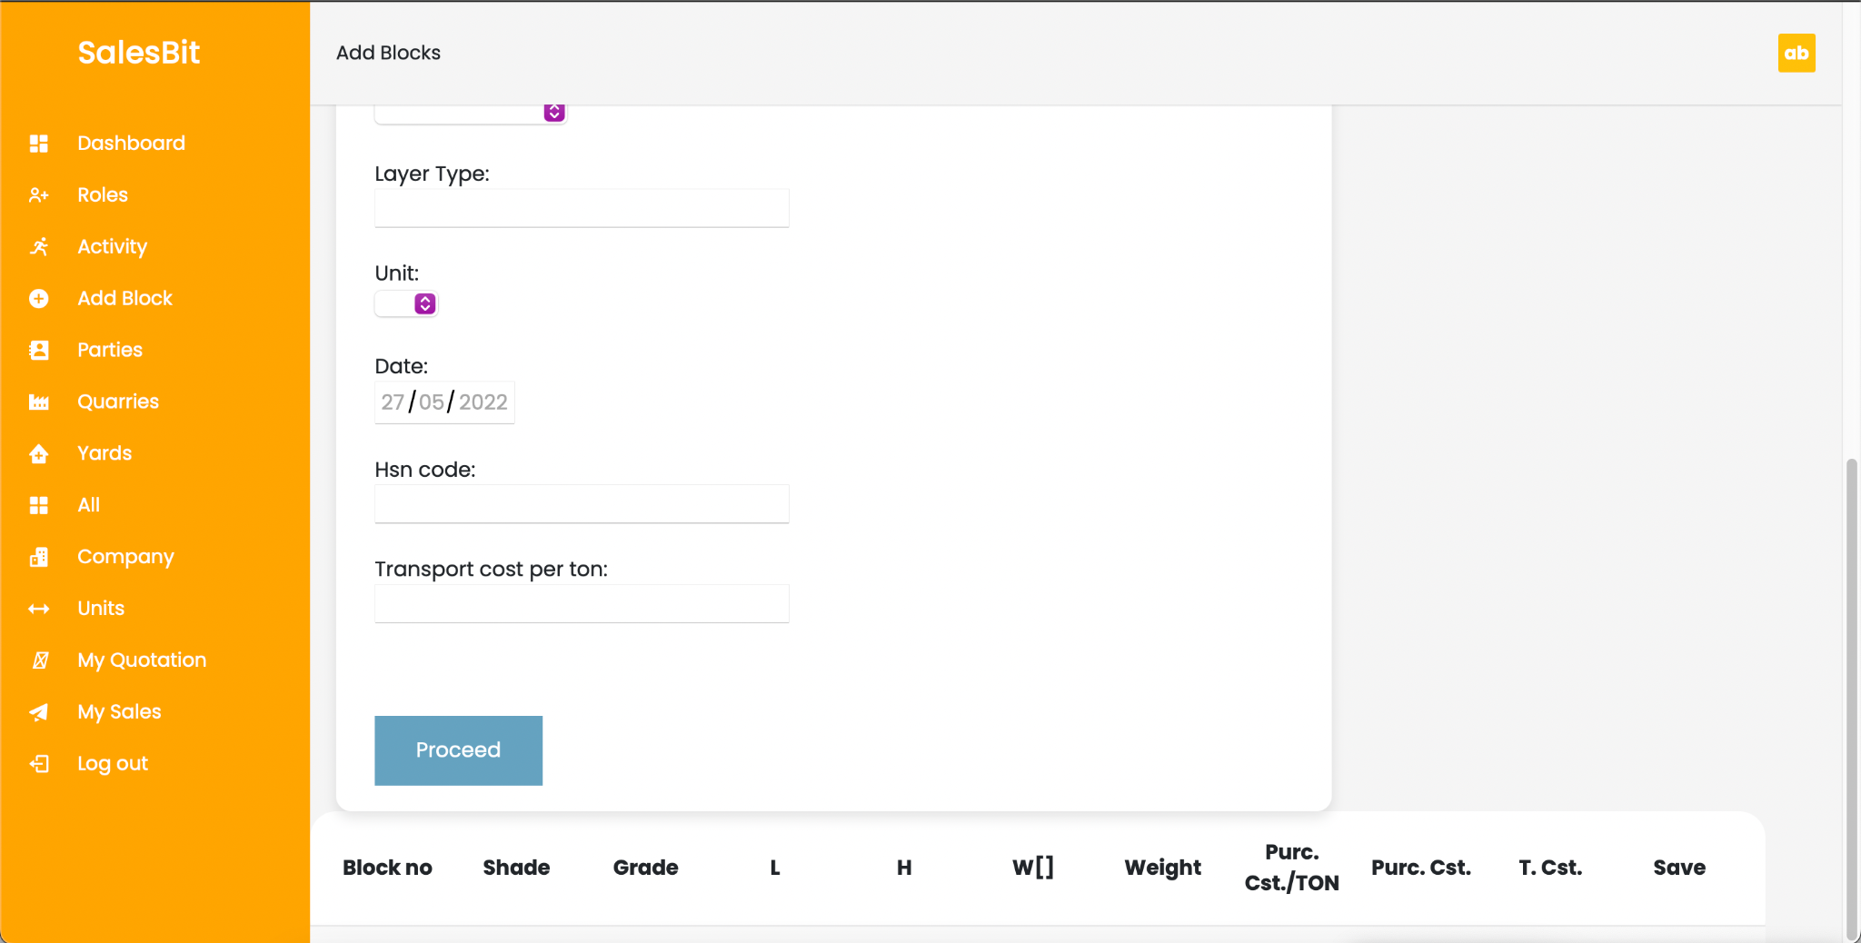

**5.4 Add Parties**

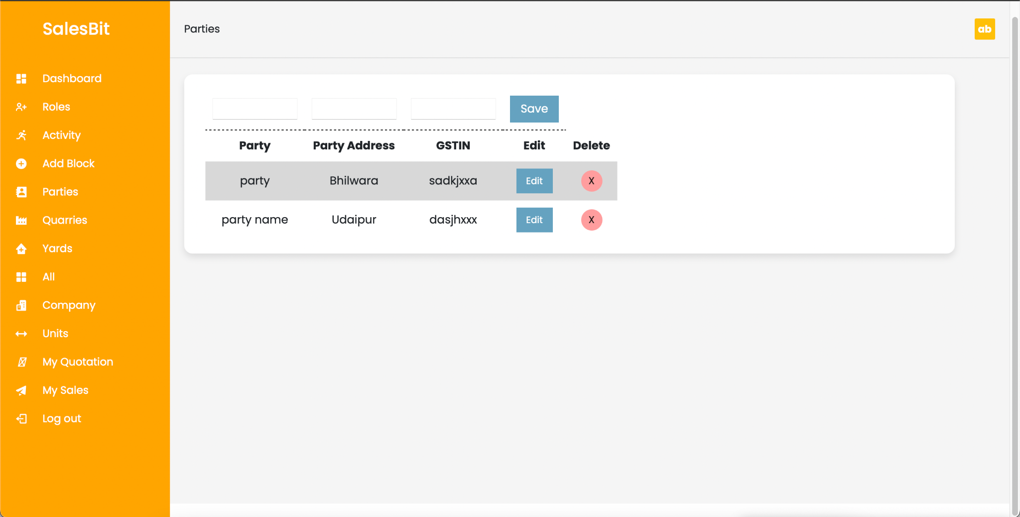

**5.5 Add Quarry**

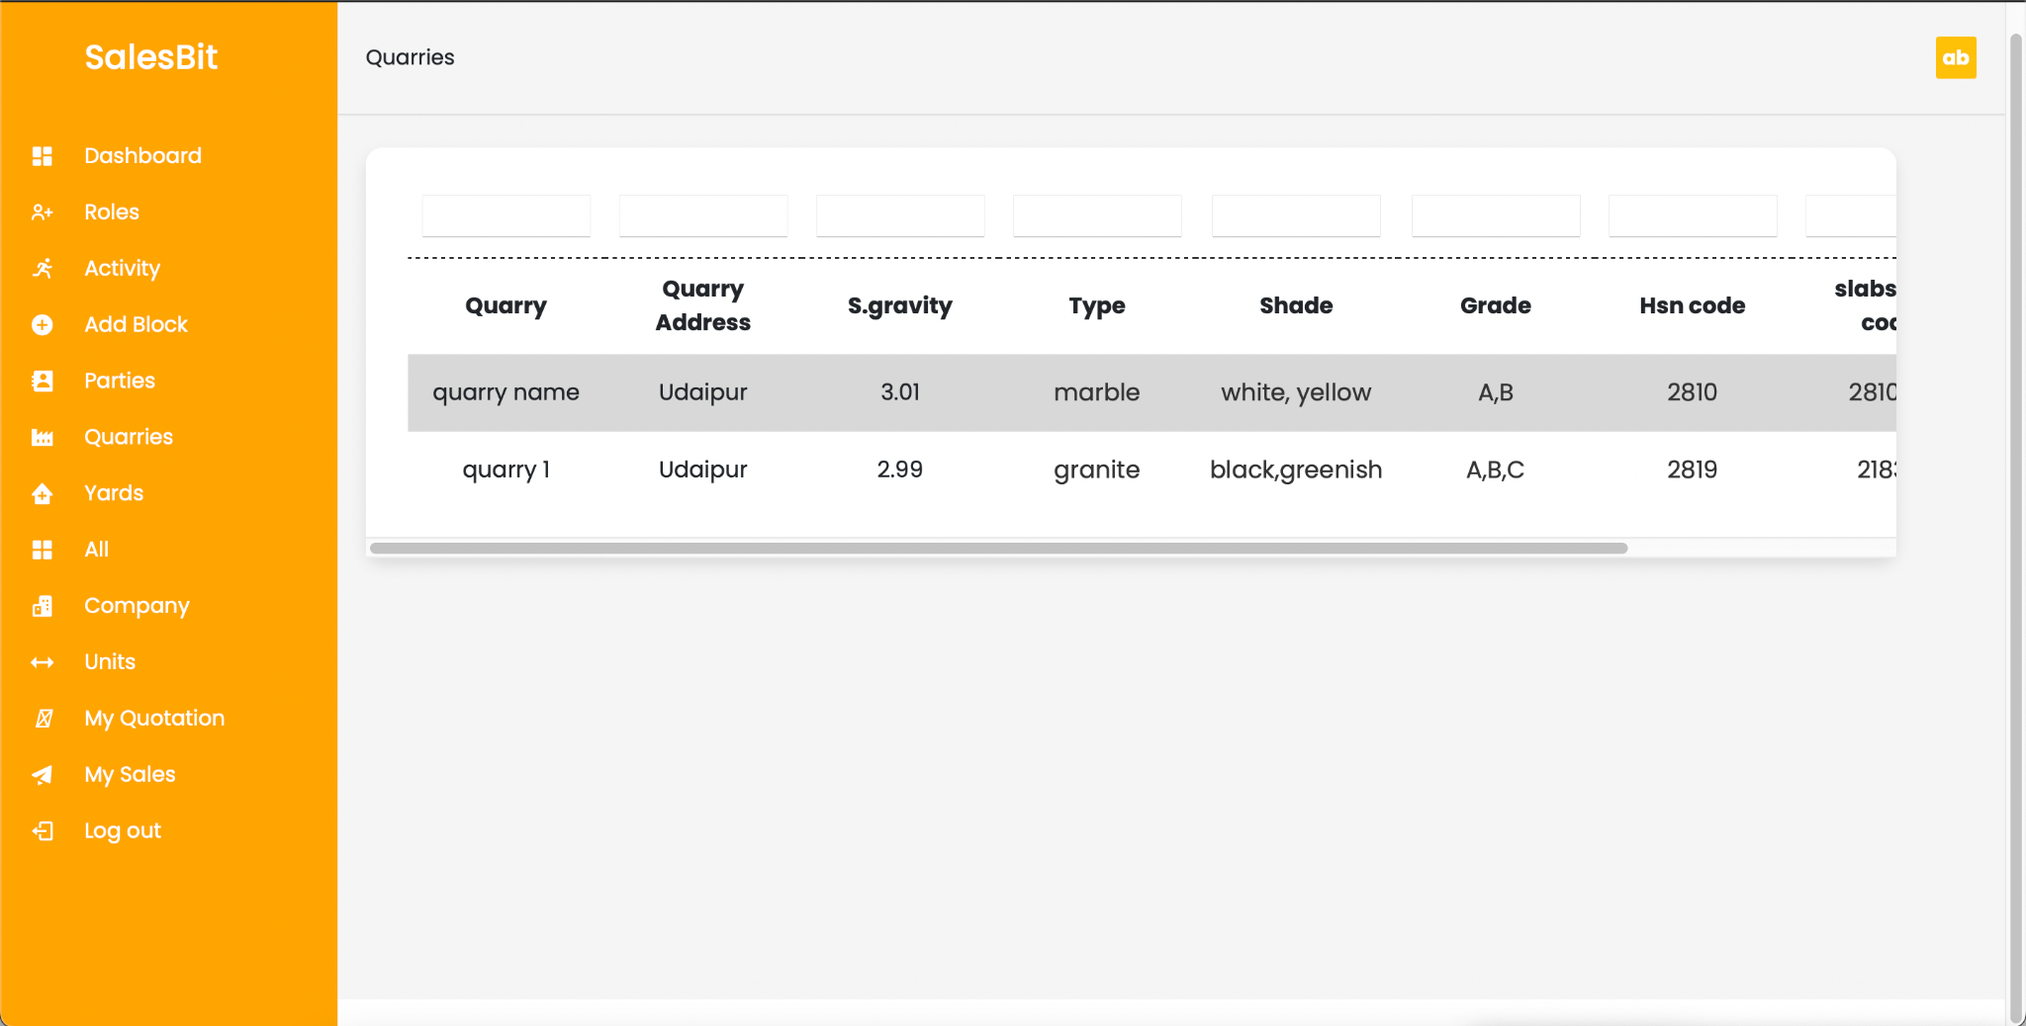

**5.6 Add Yard**

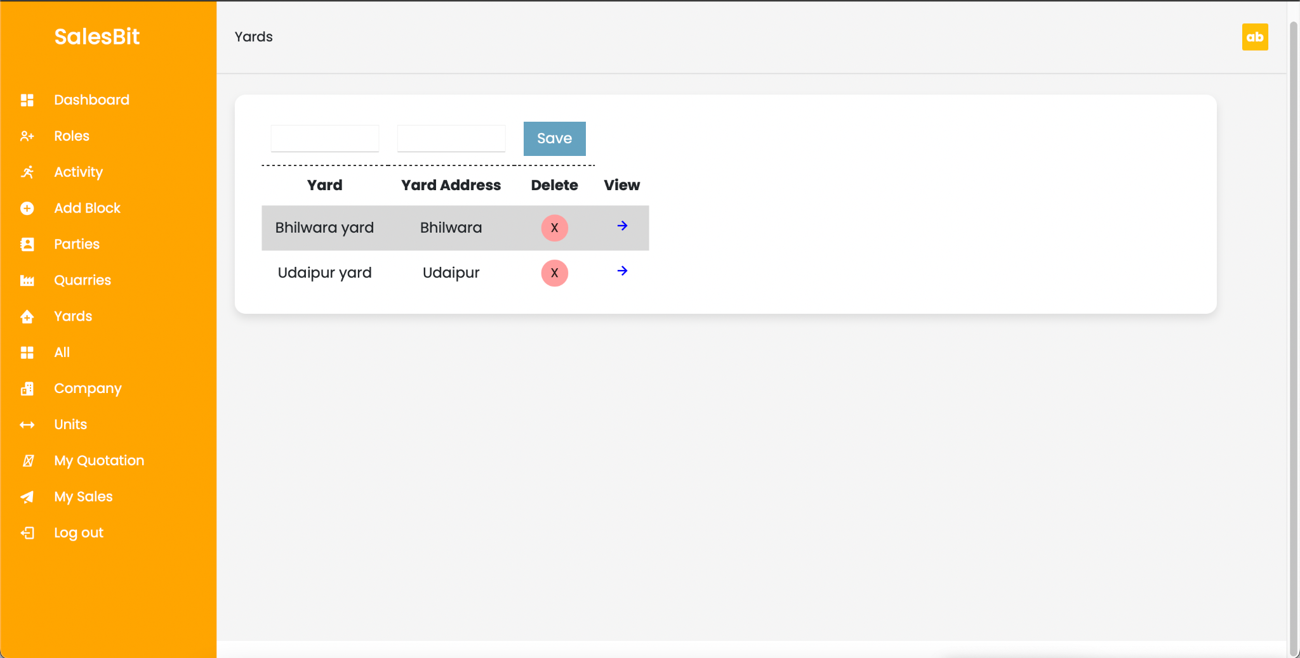

**5.7 View Inventory**

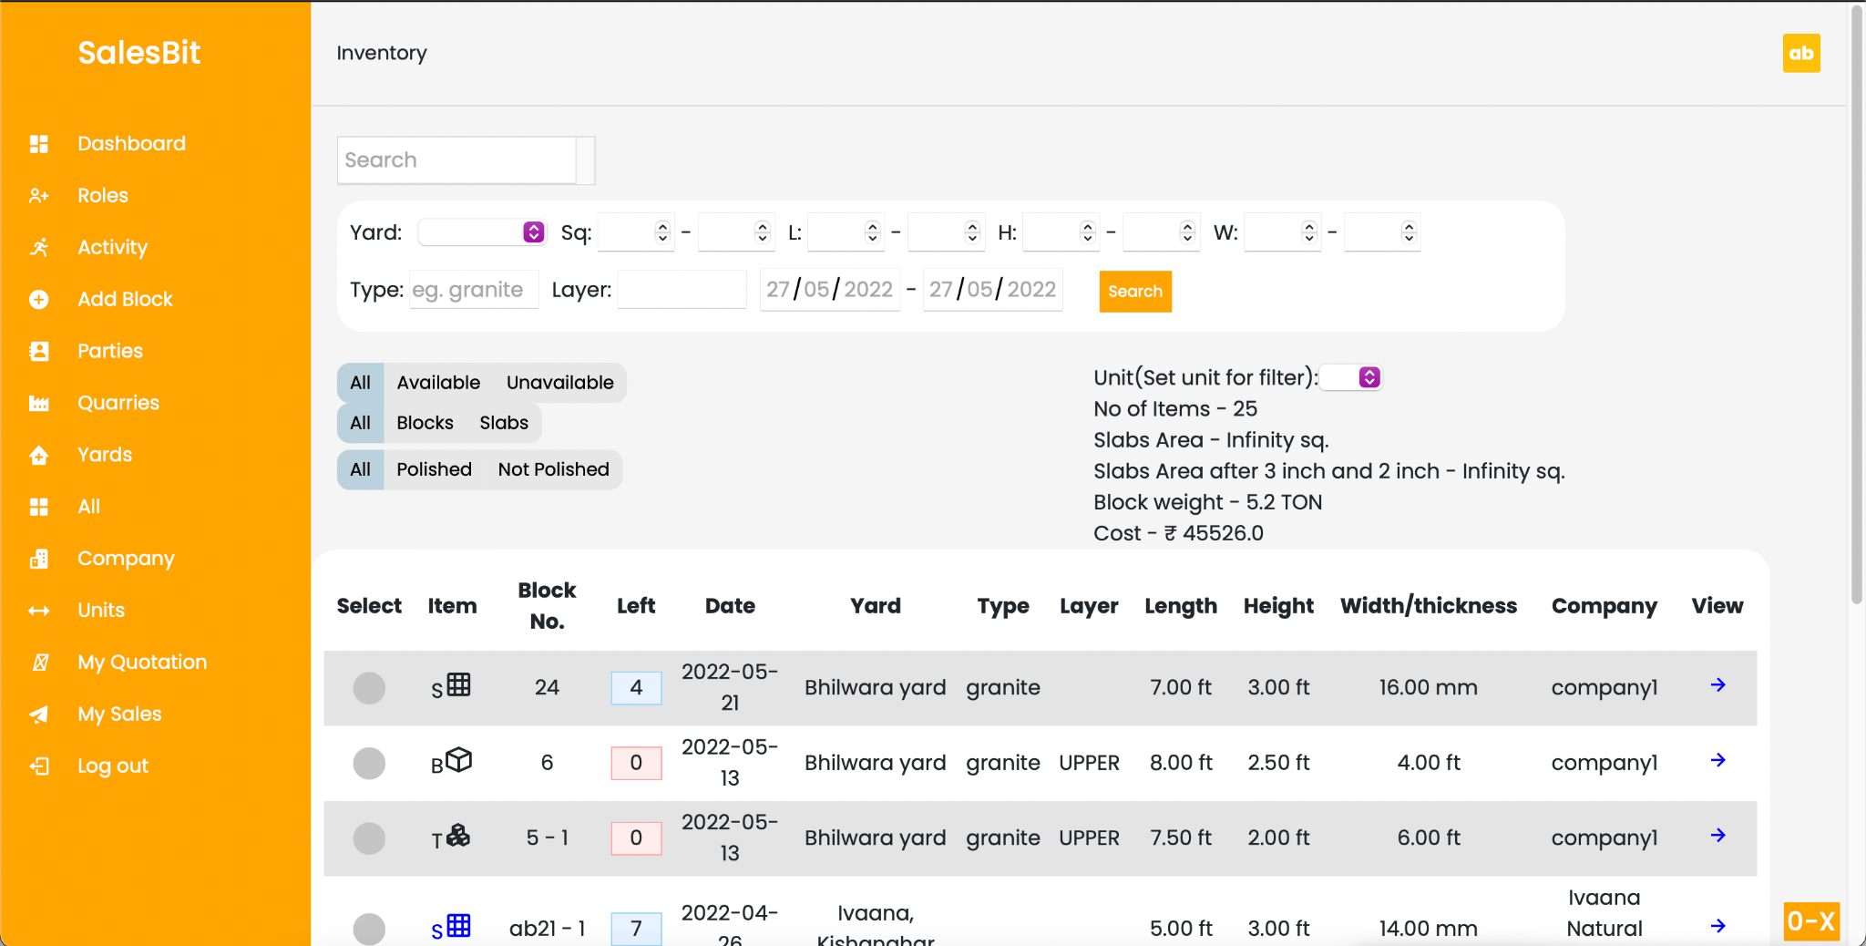

**5.8 Add Company**

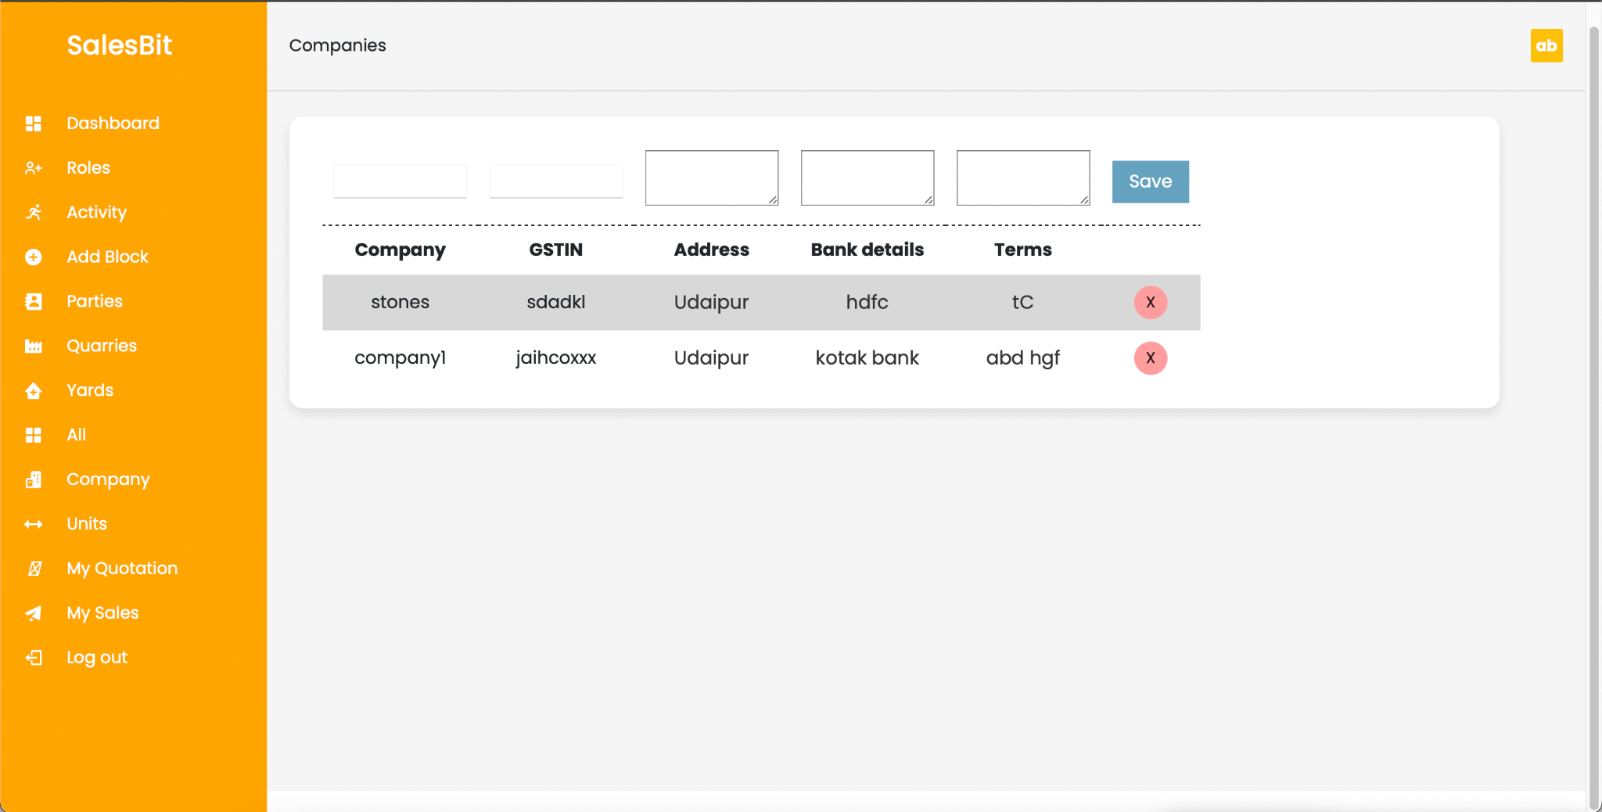

**5.9 Add Units**

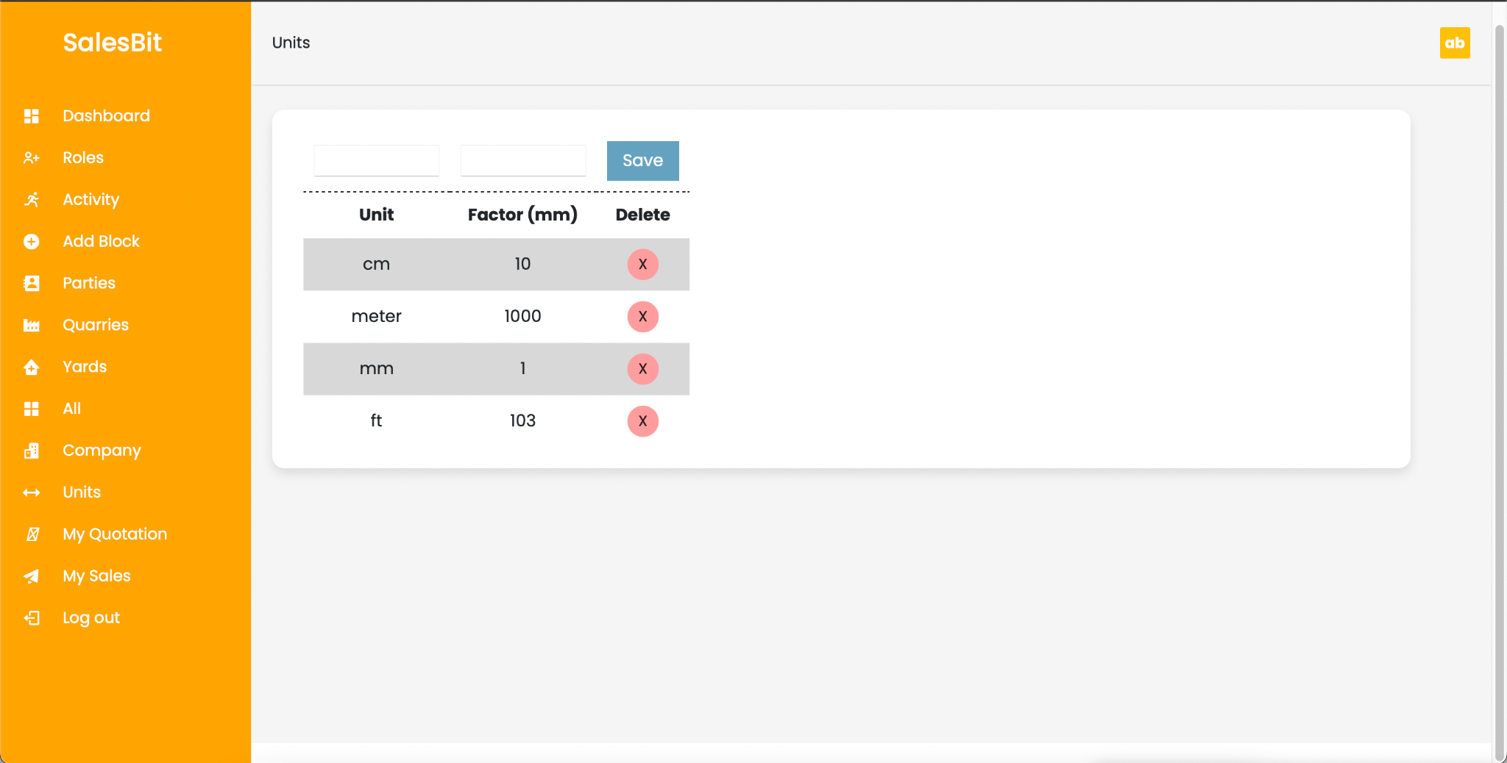

**5.10 Generate Invoice**

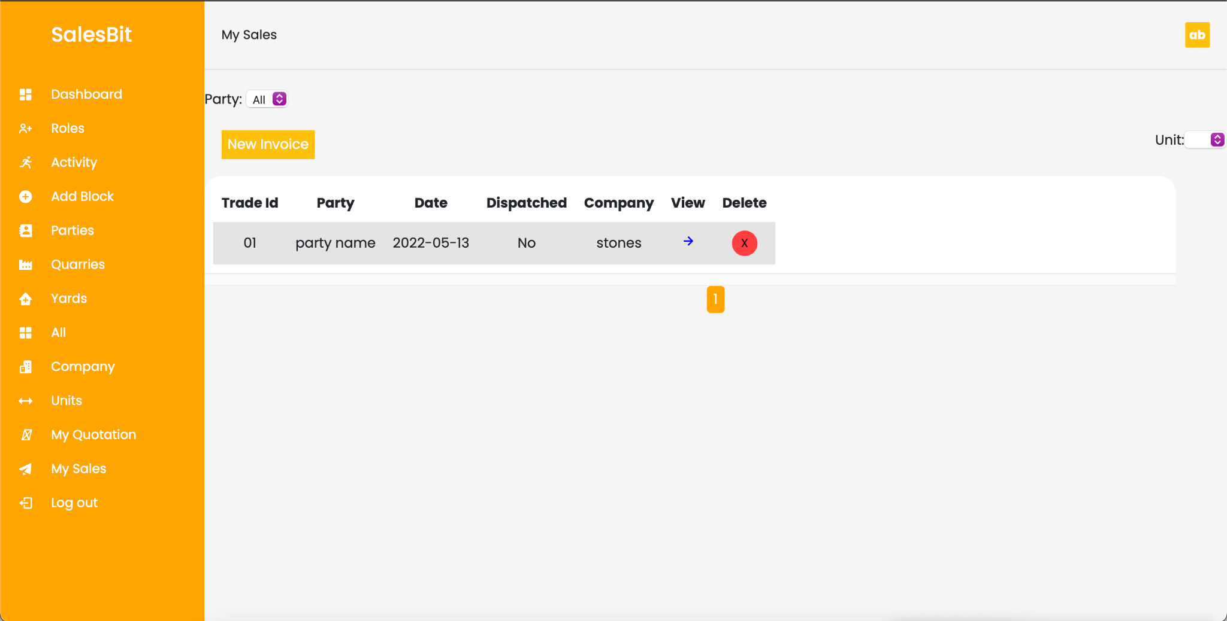

**5.11 Batch Task**

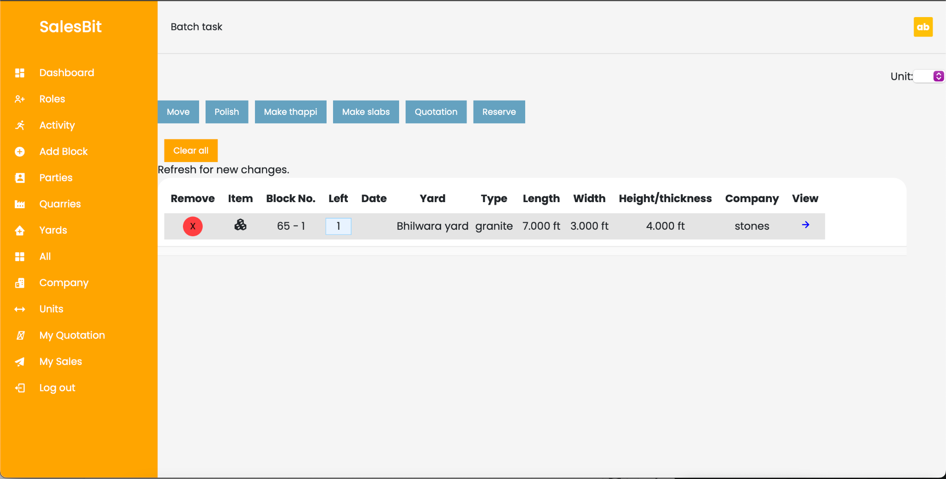

**5.22 View Role/Change password**

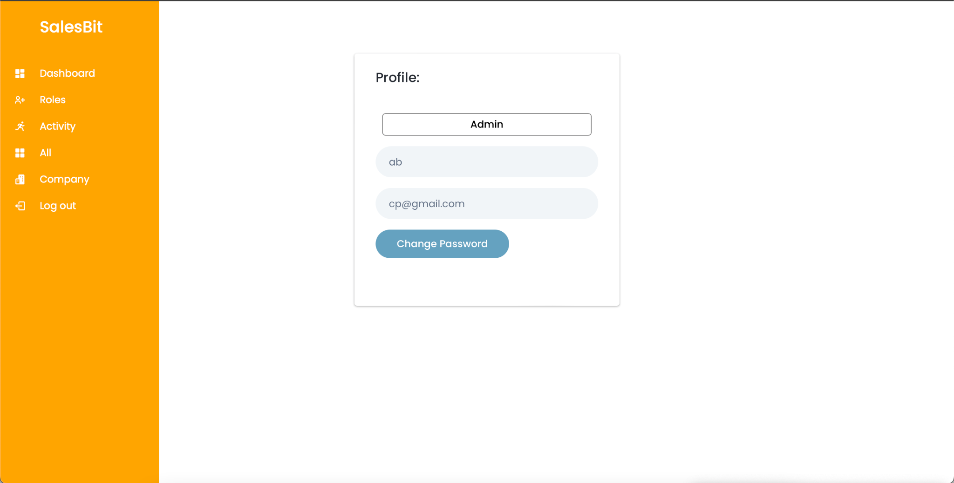

**5.23 Salesman View and options**

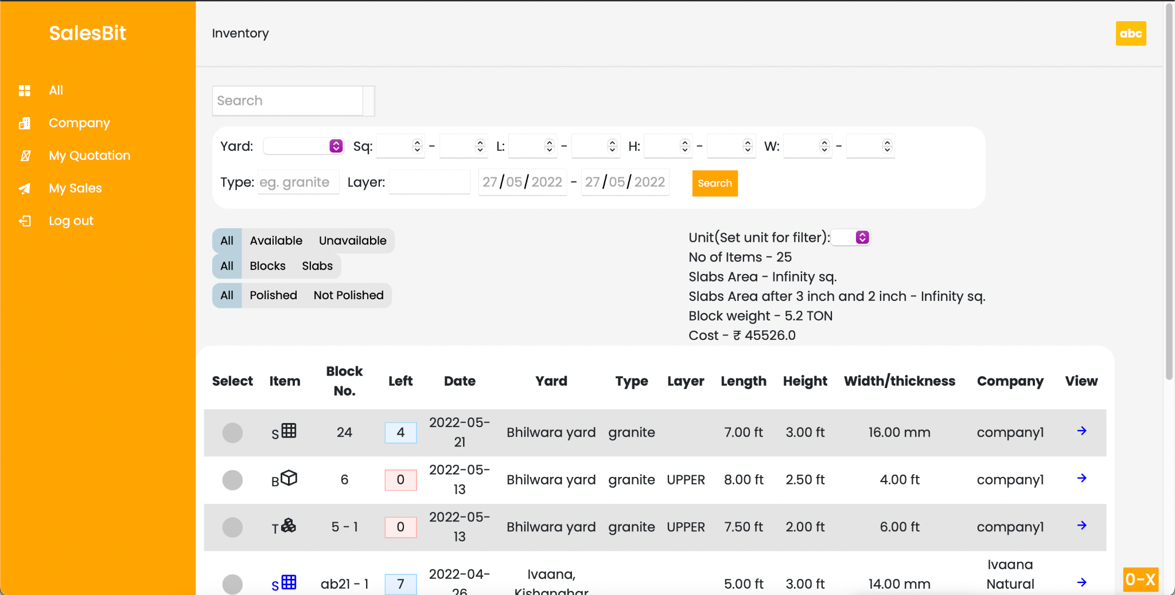

**5.24 Manager View and options**

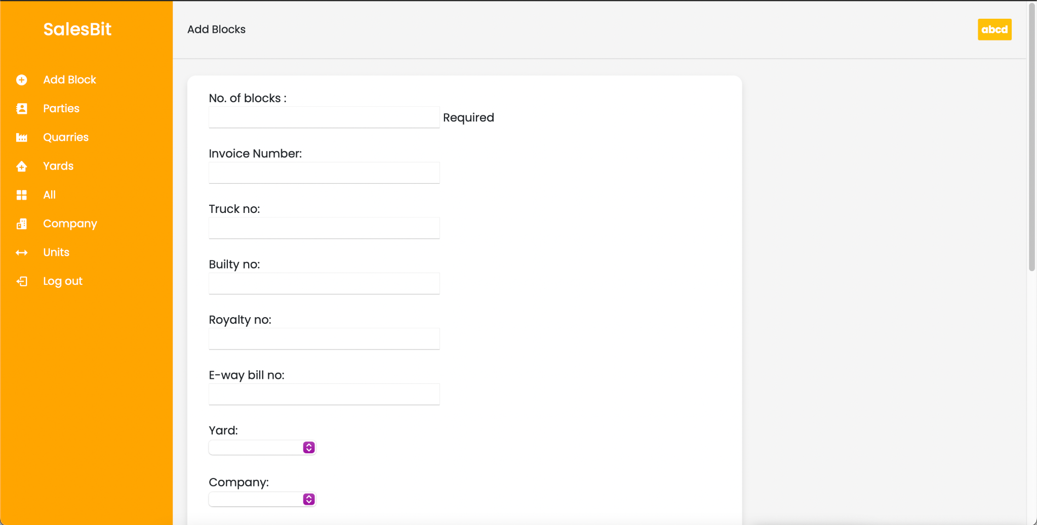

**CHAPTER – VI**

**TESTING**

**Testing Methodology**

Companies rely on software more than ever to provide and manage information with strategic and operational importance and to provide key decision support. Rising customer expectations for fault-free, requirements-exact software have increased awareness of the importance of software testing as a critical activity.

We begin the testing process by developing a comprehensive plan to test the general functionality and special features on a variety of platform combinations. Strict quality control procedures are used. The process very

fies that the application meets the requirements specified in the system requirements document and is bug free. At the end of each testing day, we prepare a summary of completed and failed tests. Applications are not allowed to launch until all identified problems are fixed. A report is prepared at the end of testing to show exactly what was tested and to list the final outcomes.

Our software testing methodology is applied in three distinct phases: unit testing, system testing, and acceptance were testing.

**Unit Testing**: The programmers conduct unit testing during the development phase. Programmers can test their specific functionality individually or with other units. However, unit testing is designed to test small pieces of functionality rather than the system as a whole. This allows the programmers to conduct the first round of testing to eliminate bugs before they reach the testing staff. In unit testing the analyst tests the programs making up a system. For this reason, unit testing is sometimes called program testing. Unit testing gives stress on the

modules independently of one another, to find errors. This helps the tester in detecting errors in coding and logic that are contained within that module alone. The errors resulting from the interaction between modules are initially avoided.

For example, a hotel information system consists of modules to handle reservations; guest checking and checkout; restaurant, room service and miscellaneous charges; convention activities; and accounts receivable billing. For each, it provides the ability to enter, modify or retrieve data and respond to different types of inquiries or print reports. The test cases needed for unit-testing should exercise each condition and option. Unit testing can be performed from the bottom up, starting with smallest and lowest-level

modules and proceeding one at a time. For each module in bottom-up testing a short program is used to execute the module and provides the needed data, so that the module is asked to perform the way it will when embedded within the larger system.

**System Testing:** The objective of system testing is to ensure that all individual programs are working as expected, that the programs link together to meet the requirements specified and to ensure that the computer system and the associated clerical and other procedures work together. The initial phase of system testing is the responsibility of the analyst who determines what

conditions are to be tested, generates test data, produces a schedule of expected results, runs the tests and compares the computer produced results with the expected results with the expected results. The analyst may also be involved in procedures testing. When the analyst is satisfied that the

system is working properly, he hands it over to the users for testing. The importance of system testing by the user must be stressed. Ultimately it is the user must verify the system and give the go-ahead. During testing, the system is used experimentally to ensure that the software does not fail, i.e.,

that it will run according to its specifications and in the way users expect it to. Special test data is input for processing (test plan) and the results are examined to locate unexpected results. A limited number of users may also be allowed to use the system so analysts can see whether they try to use it in unexpected ways. It is preferable to find these surprises before the organisation implements the system and depends on it. In many organisations, testing is

performed by persons other than those who write the original programs. Using persons who do not know how certain parts were designed or programmed ensures more complete and unbiased testing and more reliable software.

The system is tested as a complete, integrated system. System testing first occurs in the development environment but eventually is conducted in the production environment. Functionality and performance testing are designed to catch bugs in the system, unexpected results, or other ways in which the system does not meet the stated requirements. The testers create detailed scenarios to test the strength and limits of the system, trying to break it

if possible. Editorial reviews not only correct typographical and grammatical errors but also improve the system’s overall usability by ensuring that on-screen language is clear and helpful to

users. Accessibility reviews ensure that the system is accessible to users with disabilities.

System testing consists of the following five steps:

i. Program testing

ii. String testing

iii. System testing

iv. System documentation

v. User acceptance testing

**Program Testing**

A program represents the logical elements of a system. For a program to run satisfactorily, it must compile and test data correctly and tie in properly with other programs. It is the

responsibility of a programmer to have an error free program. At The time of testing the system, there exist two types of errors that should be checked. These errors are syntax and logic. A syntax error is a program statement that violates one or more rules of the language in which it is written. An improperly defined field dimension or omitted key words are common syntax

errors. These errors are shown through error messages generated by the computer. A logic error, on the other hand, deals with incorrect data fields out of range items, and invalid combinations. Since the logical errors are not detected by the compiler, the programmer must examine the output carefully to detect them. When a program is tested, the actual output is compared with the

expected output. When there is a discrepancy, the sequence of the instructions must be traced to determine the problem. The process is facilitated by breaking the program down into self-contained portions, each of which can be checked at certain key points.

**String Testing**

Programs are invariably related to one another and interact in a total system. Each program is tested to see whether it conforms to related programs in the system. Each part of the system is tested against the entire module with both test and live data before the whole system is ready to be tested.

**System Testing**

System testing is designed to uncover weaknesses that were not found in earlier tests. This includes forced system failure and validation of the total system as it will be implemented by its user in the operational environment. Under this testing, generally we Take low volumes of transactions based on live data. This volume is increased until the maximum level for each transaction type is reached. The total system is also tested for recovery and fallback after various major failures to ensure that no data are lost during the emergency. All this is done with the old system still in operation. When we see that the proposed system is successful in the test, the old system is discontinued.

**System Documentation**

All design and test documentation should be well prepared and kept in the library for future

reference. The library is the central location for maintenance of the new system.

**User Acceptance Testing**

An acceptance test has the objective of selling the user on the validity and reliability of the

system. It verifies that the system's procedures operate to system specifications and that the integrity of important data is maintained. Performance of an acceptance test is actually the user's show. User motivation is very important for the successful performance of the system. After that, a comprehensive test report is prepared. This report shows the system's tolerance, performance range, error rate and accuracy.

**Table 6.1 Test Report with test data**

**TEST REPORT WITH TEST DATA**

(To be filled by System Analyst/Programmer)

**Project Name: Salesbit**

| A. | INTERFACE TESTING  1) User-friendliness  2) Consistent menus | OK  NA |
| --- | --- | --- |
| B. | CONTROL FLOW TESTING  1) IF-THEN-ELSE  2) DO WHILE  3) CASE-SWITCH | OK  OK  OK |
| C. | VALIDATION TESTING  1) Check for improper or inconsistent typing  2) Check for erroneous initialization or default values  3) Check for incorrect variable names  4) Check for inconsistent Data Types  5) Check for relational/arithmetic operators | OK  OK  OK  OK  OK |
| D. | DATA INTEGRITY/SECURITY TESTING  1) Data Insertion/ Deletion/ Updating  2) Boundary condition (Underflow, Overflow Exception)  3) Check for unauthorised access of data  4) Check for data availability | OK  OK  OK  OK |
| E. | EFFICIENCY TESTING  1) Throughput of the system  2) Response time of the system  3) Online disk storage required by the system  4) Primary memory required by the system | OK  OK  OK  OK |
| F. | ERROR HANDLING ROUTINES  1) Error description are intelligent/ understandable  2) Error recovery is smooth  3) All error handling routines are tested and executed at least once | OK  OK  OK |

**CHAPTER – VII**

**CONCLUSION AND FUTURE ENHANCEMENTS**

**7.1 Limitations:**

This webapp requires internet connectivity at all times to function.

Note-taking and data management are still preferred to be done on paper because the working staff is not accustomed to using computers.

**7.2 Future enhancements:**

In the future, some more enhancements can be made to this webapp. Some of them are:

-> Auto reading of scanned report to enter data.

-> Advanced sales reports for proper analysis of the overall growth of the company.

**7.3 Conclusion:**

This solution will solve the problem of stock and sales management for the excavation/mining industry. This can also reduce the manpower required for managing the data during the process thus improving the business efficiency. This web application covers all the aspects of stock and sales management from the excavation of stone to processing to selling it off.

**CHAPTER - VIII**

**Project Timeline**

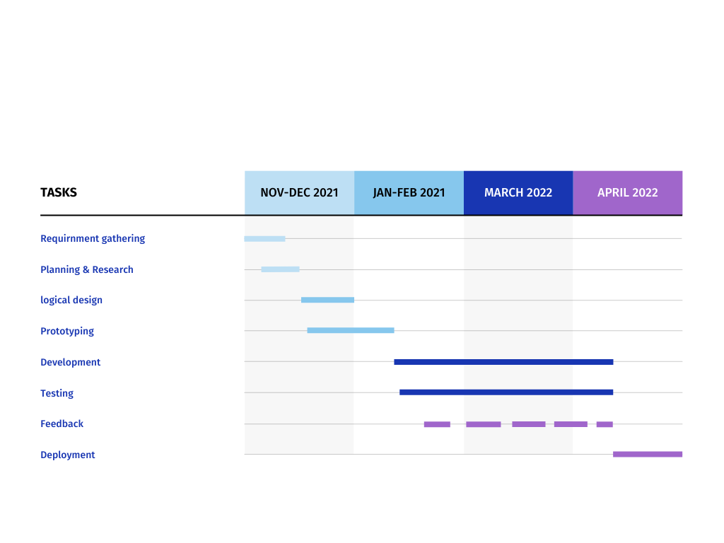

Fig. 6

Project timeline

This project is divided into 8 phases namely Requirement gathering, Planning and Research, Logical design, Prototyping, Development, Testing, Feedback, and Deployment.

After the month of April 2022, end-user testing was carried out.

It has been thoroughly tested and is currently deployed.

**CHAPTER – IX**

**BIBLIOGRAPHY & DEPENDENCIES**

**References and Bibliography:**

CodingLabWeb.com - for frontend template

Boxicons - for icons

Stack Overflow - for issue resolution

**Dependencies:**

* Mongoose - for database layer
* Jsonwebtoken - for token verification
* Bcryptjs - to hash passwords before storing
* Nodemailer - for password recovery